Jonathan Quang Math Research

Pi, More than a Ratio

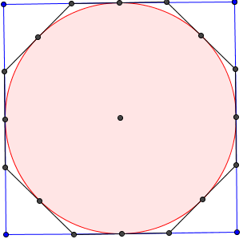 *Π* is the ratio of the circumference of a circle to its diameter, used by students since elementary school. However, there is more to *π* than a simple ratio. People expect values of *π* to be calculated just by pressing a button, but how is it done without a machine?

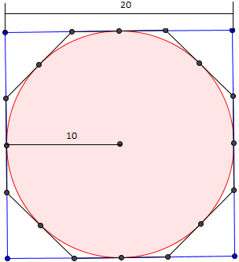 The problem with *π* is that it is irrational. An irrational number is a number whose value cannot be expressed as a ratio between integers such as $\sqrt{2}$. The common approximations of *π* are $\frac{22}{7}$ which is only accurate up to two digits, $\frac{333}{36}$ which is accurate only to five digits, and $\frac{355}{113}$. There will never be an exact fraction, but there is a way to find these fractions.  
 One way to approximate *π* is through the application of Pythagoras’s theorem to a circle inscribed in a regular concave polygon. Using a circle inscribed in a regular concave polygon inscribed and inscribed in another regular concave polygon with 2 times the number of side will yield a high end approximation. A common polygon to start with is a square. Imagine a circle inscribed within a square and inscribed within an octagon, as with the picture below. Archimedes used a method similar to this, but he used a hexagon.  
 Say the radius of the circle is 10. Now the square’s side is twice the radius, 20. The perimeter of the square is four times a side, so here the perimeter of the square is 80. The diameter of this circle is 20. *Π* is defined as the ratio of the perimeter to the diameter, so the ratio is $\frac{80}{20}$, or 4. However, finding *π* using a regular concave octagon becomes slightly more complicated. It is acknowledged that the length of the midpoint on one side of the square to another side of the square is 10. The midpoints of the sides also function as midpoints of the sides of the octagon. The goal is to find the length between a midpoint of the side of an octagon to one of the vertices 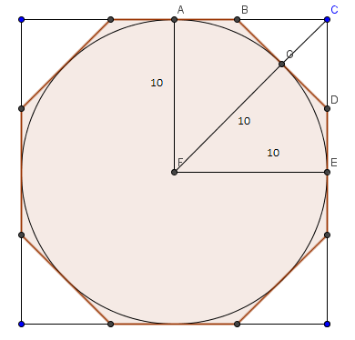of the octagon. We define this length (such as AB) as *b*. If one draws two triangles that each use a measurement of *b* and another variable, then *b* can be found. This is accomplished by drawing a line segment from one vertex of the square to the center of the circle. The length of this segment with the radius removed (GC) is defined as *c*. The radius is represented by *r*, and although a will not be used yet, it represents half the length of the polygon with less sides. Now two right triangles have been formed. Applying Pythagoras’s theorem (a2+b2=c2) to two of these triangles yields *b*2 + *c*2 = (10 – *b*)2 in triangle CGD and (10+*c*)2 = 102 + 102 in triangle CEF. The overall goal is to find *b* through substitution by isolating *c* first. In *b*2 + *c*2 = (10 – *b*)2, *b*2 can be subtracted from both sides to get *c*2 = (10 – *b*)2 – *b*2. Squaring the binomial contained in the 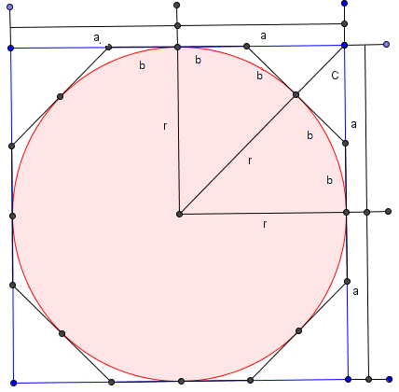parentheses yields *c*2 = 100-20b +*b*2 – *b*2, which simplifies to *c*2 = 100 – 20b. With (10+*c*)2 = 102 + 102, square rooting both sides will yield 10+*c* = $\sqrt{{10}^{2}+{10}^{2}}$. Subtract 10 from both sides and *c* = $\sqrt{{10}^{2}+{10}^{2}}$– 10. *c* is now isolated on both sides of the equation, *c*2 = 100 – 20b and *c* = $\sqrt{{10}^{2}+{10}^{2}}$– 10. Substitute the *c* and now ${(\sqrt{{10}^{2}+{10}^{2}} – 10)}^{2}$ = 100 – 20*b*. Subtract 100 from both sides of equation, and now ${(\sqrt{{10}^{2}+{10}^{2}} – 10)}^{2}$- 100= -20b. After evaluating the left side of the equation, -82.8427…= -20*b*. Dividing both sides by -20 will finally yield the value of b, which is 4.14213569…  
 With the value of *b* evaluated, the perimeter of the octagon can now be found out. Since *b* represents the length of one half of a side on the octagon, 2b represents the length of one side. Since the octagon is equilateral, all 8 sides are equal, so the perimeter is 8*2b, or 16b. This makes the perimeter about 66.27416998… The diameter of the circle is 20 because the diameter is twice the radius, 10. The ratio of *π* is defined as the ratio between the perimeter of a circle and its diameter. Since the octagon is being used to approximate the perimeter of a circle, *π* is about $\frac{66.27416998…}{20}$ or about 3.313708.

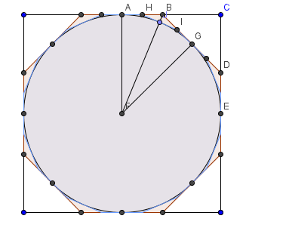This process can be expanded with the addition of the next polygon that has a number of sides that are powers of 2. JB is defined as the new *c* length since it connects a midpoint of one side of the 16-gon (hexadecagon) to a vertex of the shape before it, the octagon. The new *b* length is AH (half the side of a hexadecagon), which is also equal to HJ, JI, and IG. It cannot be assumed that H lies on a point that divides one side of the octagon into quarters. The length AB and all lengths equivalent to AB shall be represented by a (which is the old *b* value,   
4.14213569 ...). In right triangle HJB, HJ is represented by a-b. The application of Pythagoras's theorem is (*a*-*b*)2 = *b*2 + *c*2, which becomes In right triangle BAF, (10+*c*) 2=102 + *a*2, which is equivalent to $c= \sqrt{{10}^{2}+a^{2}}$-10. Plugging this into the *c* of (*a*-*b*)2 = *b*2 + *c*2, plugging in the a value, and solving for *b* will result in 1.989123... The perimeter of the hexadecagon is 32*b*, which comes out to 63.651957... The perimeter over the diameter, 20, puts *π* at about 3.182578... Repeating this process with the next polygon with a number of sides that is a power of 2 will yield more accurate approximations of *π*.

To find the low end estimate, the ratio of the perimeter of a regular concave polygon inscribed within a circle to the circle’s diameter must be found. Once again, polygons with a power of 2 number sides will be used exclusively. If a square is inscribed within a circle with a radius of ten, the length of a segment from one vertex to the center of the square is the same as the radius. Two segments formed from two adjacent vertices forms a right triangle where the hypotenus is the length of the radius and the lengths of the triangle are equal. Using one’s knowledge of pythagorean triple, if the legs of a right triangle are equal, then the hypotenuse is $\sqrt{2}$ multiplied by the length of one leg. Since each side of the square is $\sqrt{2}$ times the radius, the perimeter of the square is 4 $\sqrt{2}$ times the radius, 10, and the diameter is 20. This makes the perimeter of the square 40 $\sqrt{2}$. This makes the low estimate of *π* to be about $\frac{40\sqrt{2}}{20}$, which is   
2 $\sqrt{2}$ or 2.82842125...

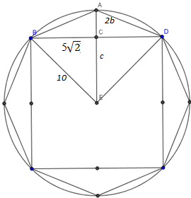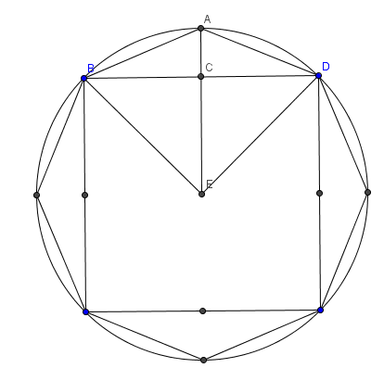Much like finding the high end estimate, finding the perimeter of a regular concave octagon inscribe within the circle becomes more complex. Unlike finding the high end estimate, the square is inscribed within the octagon, which is then inscribed within the circle. Each side of the square is 10 $\sqrt{2}$ (making the length from the midpoint of a square's side to a vertex 5 $\sqrt{2}$), the radius is 10, 2*b* represents the length of one side of the octagon, and *c* represents the length CE drawn from the center of a midpoint of the octagon to the center of the circle. The distance of a segment from the midpoint of the square to the vertex of the octagon is 10-*c*. There are two right triangles in the diagram. One right triangle has the legs  *c* and 5 $\sqrt{2}$ and a hypotenuse of 10 (the radius). Applying pythagoras's theorem to this right triangle will result in *c*2 + (5)2 = 102. Subtracting (5)2 from both sides will result in *c*2 = 102 -(5)2 Square rooting both sides will yield $c= \sqrt{{10}^{2}-{(5\sqrt{2})}^{2}. }$ In the right triangle created by the legs 5 $\sqrt{2}$ and *c*, and the hypotenuse, 2*b*, the application of Pythagoras's theorem comes out to ${(5\sqrt{2})}^{2}+{(10+c)}^{2}= {(2b)}^{2}$. Squaring the 2*b* gets ${(5\sqrt{2})}^{2}+{(10-c)}^{2}= {4b}^{2}$. These two equations now share a term in common, c. By substituting the first equation into the second equation, the variable *c* has been eliminated and ${(5\sqrt{2})}^{2}+{(10-\sqrt{{10}^{2}-{(5\sqrt{2})}^{2} })}^{2}= {4b}^{2}$. Evaluating the value of the left side of the equation, dividing it by 4, and then square rooting it will have *b* to be about 3.82684324. Recall that the length of each side is 2*b* and there are 8 sides. This makes the perimeter of the regular octagon 16*b*. Evaluating this expression will yield 61.22934918... Remember that the diameter of the circle is 20. Calculating the ratio of *π* with the perimeter of the octagon as an approximation will yield 3.031467459... To get an even more accurate estimate, the number of sides with the next regular polygon must double.

To get the perimeter of a hexadecagon inscribed in a circle, 2*b* now represents length BF in the diagram on the next page. *c* now represents length FG. A new variable will be used, *a*, which represents the length of half of one side of the previous polygon, otherwise known as the old *b* in BG. From triangle EGB, c2+a2= 102, which is equivalent to c= $\sqrt{{10}^{2}-a^{2}}$. From triangle BGE, a2+(10-c)2 = (2b)2. If we substitute c= into *a*2+(10-*c*)2 = (2*b*)2, plug in *a*, and solve for *b*, the result is 1.952784... Each side of the hexadecagon is 2*b*, and there are 16 sides. 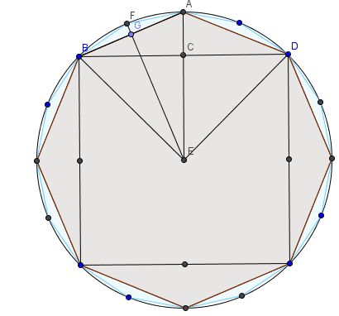That means the perimeter is 32*b*. This equals 62.489091... The perimeter over the diameter of 20 will yeild an approximation for *π* that is around 3.121445... The proccess can be repeated for the next polygon with twice the number of sides for a more accurate approximation.   
 Concave regular polygons with more sides are used to get more accurate values because the more sides such a polygon has, the more it actually looks like a circle. Just look at the *π*cture above. The hexagon is closer to the edges of the circle than the square. The hexadecagon is even closer. Below is a table that summarizes the approximations for *π* done in this paper.

|  |  |  |  |
| --- | --- | --- | --- |
| **Polygon** | **Interior Polygon Approximation for *pi*** | **Exterior Polygon Approximation for *pi*** | **Average** |
| Square | 2.82842712474619 | 4 | 3.41421356237309 |
| Octagon | 3.06146745892072 | 3.31370849898476 | 3.18758797895274 |
| Hexadecagon | 3.12144515225805 | 3.18259787807453 | 3.15202151516629 |

Another way to calculate *π* requires some knowledge of trigenometery. Specifically the arctangent function will be used. The tangent function in a right triangle takes in an angle value and returns the ratio of the opposite side to the adjacent side. The arctangent function does the inverse, it takes in a ratio and returns the angle, but here, it will return the arc length. To utilize this function to find the value of *π*, one must have knowledge of the special right triangles.  
 The special right triangles used here are the 45-45-90 and 30-60-90 right triangles. The 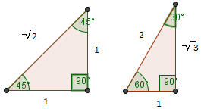sides opposite the angles with those measures are in a special ratio of 1:1: $\sqrt{2}$ and 1 : $\sqrt{3}$:2 The ratio of 1:1 would mean that arctan would equal 45 degrees. The ratio of 1: $\sqrt{3}$ would mean that arctan would equal 30 degrees.

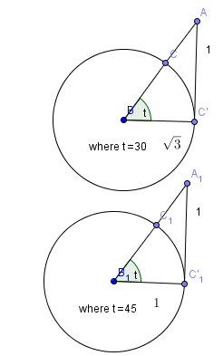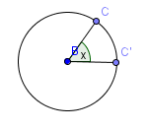The formula for the circumference of a circle is *π\**diamater. The diameter of a circle is twice the radius, which makes the circumference of a circle also *π*2\**radius. Say *x* is the measure of the central angle of a circle. The "center" of a circle is 360o. If x was 360o, then 360/x would represent the entire circumference. However, if x was a different value, then 360/x would have to represent an arc length of $\frac{π*2*radius}{360/x}$ because 360/x determines how much of the arc is contained within the central angle.   
 Using this knowledge, 45 degrees would be represent an arc length of *π*/4 and 30 degrees would represent an arc length of *π*/6 . There is a series that allows for arctan to be calculated written by James Gregory in 1672. Where t is a tangent for angles up to 45 degrees, arctan(t) = $t-\frac{t^{3}}{3}+\frac{t^{5}}{5}-\frac{t^{7}}{7}+\frac{t^{9}}{9}$...Note that with any tangent for angles above 45 degrees, the corresponding ratio is actually greater than 1 in absolute value. The sum of the series will actually begin to diverge away from a number rather then get closer to a number. Say we use 45 degrees. T would be the ratio, 1/1, or just 1, arctan(1)=45 degrees. The equation is now arctan(1)= $1-\frac{1^{3}}{3}+\frac{1^{5}}{5}-\frac{1^{7}}{7}+\frac{1^{9}}{9}$... It is also known that 45 degrees = *π*/4 , and thus arctan(1)=*π*/4. By substitution of arctan(1), *π*/4 = $1-\frac{1^{3}}{3}+\frac{1^{5}}{5}-\frac{1^{7}}{7}+\frac{1^{9}}{9}$... Multiplying both sides by 4, *π* = 4($1-\frac{1^{3}}{3}+\frac{1^{5}}{5}-\frac{1^{7}}{7}+\frac{1^{9}}{9}$...). 1 to any positive integer power is just 1, so *π* = 4($1-\frac{1}{3}+\frac{1}{5}-\frac{1}{7}+\frac{1}{9}$...). With each fraction being one term, it would actually take five million terms just to get *π*/4 to 6 or 7 decimal places. This series is specifically called Lebinitz's series. However, continuing with Gregory's series, using 30 degrees results in utilizing less terms. If an angle is 30 degrees, the ratio of the opposite and adjacent angles is $\frac{1}{\sqrt{3} }$. The arctan( $\frac{1}{\sqrt{3} }$)= 30 degrees and arctan( $\frac{1}{\sqrt{3} }$)= *π*/6. Arctan( $\frac{1}{\sqrt{3} }$)= $\frac{1}{\sqrt{3} }-\frac{{(1/{\sqrt{3} })}^{3}}{3}+\frac{{(1/{\sqrt{3} })}^{5}}{5}-\frac{{(1/{\sqrt{3} })}^{7}}{7}+\frac{{(1/{\sqrt{3} })}^{9}}{9}$. This simplifies to arctan $( \frac{1}{\sqrt{3} } )= \frac{1}{\sqrt{3} }-\frac{1}{3*3\sqrt{3}}+\frac{1}{5*3^{2}\sqrt{3}}-\frac{1}{7*3^{3}\sqrt{3}}+\frac{1}{9*3^{4}\sqrt{3}}$...Substituting arctan( $\frac{1}{\sqrt{3} }$)= *π*/6 yields *π*/6 = $\frac{1}{\sqrt{3} }-\frac{1}{3*3\sqrt{3}}+\frac{1}{5*3^{2}\sqrt{3}}-\frac{1}{7*3^{3}\sqrt{3}}+\frac{1}{9*3^{4}\sqrt{3}}…$ Factoring out $\frac{1}{\sqrt{3} }$ results in *π*/6= $\frac{1}{\sqrt{3} }(1-\frac{1}{3*3}+\frac{1}{5*3^{2}}-\frac{1}{7*3^{3}}+\frac{1}{9*3^{4}}…$). Multiplying both sides by 6 will have *π* =2 $\sqrt{3}(1-\frac{1}{3*3}+\frac{1}{5*3^{2}}-\frac{1}{7*3^{3}}+\frac{1}{9*3^{4}}…$). This series calculates *π* to 3.14159, which is up to 5 decimal digits with only ten terms. While this series gets to *π* in less time than Lebinitz's series, calculating with the $\sqrt{3}$ without a calculator is much more tedious. There are many more serieses that calculate *π* in less terms, however this is as basic as it gets.

To conclude, there are multiple ways to calculate *π*. Some methods involve utilizing concave regular polygons inscribed in circles and circles inscribed in concave regular polygons. Other methods involve finding ways to calculate *π* using converging serieses. This special ratio today is rarely calculated past a few million digits. Today, calculating the millions of digits of *π* exists as a technical and mathematical challenge. Machines with better proccessors than its predeseccors can calculate *π* quicker, and people who come up with even more clever ways of calculating *π* will find *π* even more quickly.

Works Cited

1. Hemphill, Boyd E., and John C. Polking. "Degree/Radian Circle." *Degree/Radian Circle*. N.p., n.d. Web. 05 Jan. 2015.
2. Knott, R. "*Pi* and the Fibonacci Numbers." *Pi and the Fibonacci Numbers*. University of Surrey, n.d. Web. 05 Jan. 2015.
3. "*Pi* from Pythagoras." *Pi from Pythagoras*. Physics Insight, 4 June 2014. Web. 05 Jan. 2015.
4. Woltermann, M. "Gregory's Arctangent Series." *Gregory's Arctangent Series*. N.p., n.d Web. 05 Jan.2015